**FAST ITERATVE SOLVERS**

**PROJECT 3: Finding Maximum Eigen Value**

**Rohan Krishna Balaji – 403596**

***1. Run the power method for 100, 500, 1000, and 5000, iterations and Record the error, and the runtime for each of those runs.***

For: **nos6.mtx**, it converges to given tolerance of 10^-8 in **781 iterations** and error is the difference of largest eigenvalue between successive iterations

|  |  |  |
| --- | --- | --- |
| **ITERATIONS** | **ERROR** | **ELAPSED TIME (sec)** |
| 100 | 1.284*10^3 | 0.638790 |
| 500 | 5.1602*10^-4 | 0.665496 |
| 1000 | 9.31*10^-10 | 0.673188 |
| 5000 | 0 | 0.864531 |
| 1000(with tolerance limit) | 7.45*10^-9 | 0.661298 |
| 5000(with tolerance limit) | 7.45*10^-9 | 0.720034 |

(these are the values taken without setting the tolerance limit, if not mentioned otherwise)

Recorded Eigan Valure: 7.65 * 10^6

For: **s3rmt3m3.mtx**, it converges to given tolerance of 10^-8 in **2145 iterations** and error is the difference of largest eigenvalue between successive iterations

|  |  |  |
| --- | --- | --- |
| **ITERATIONS** | **ERROR** | **ELAPSED TIME (sec)** |
| 100 | 0.9564 | 37.22 |
| 500 | 0.0041 | 37.93 |
| 1000 | 1.9078*10^-5 | 38.67 |
| 5000 | 1.8*10^-12 | 45.54 |
| 5000 (with tolerance limit) | 9.98*10^-9 | 42.43 |

(these are the values taken without setting the tolerance limit, if not mentioned otherwise)

Convergence Plots for nos6.mtx for varying number of iterations

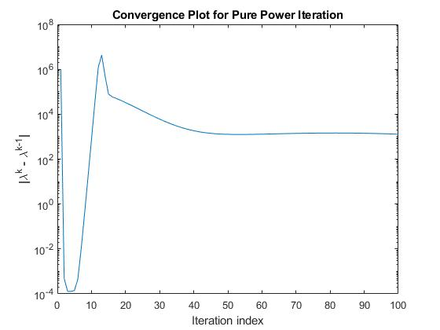

100 Iterations (tolerance of 10^-8 is not met)

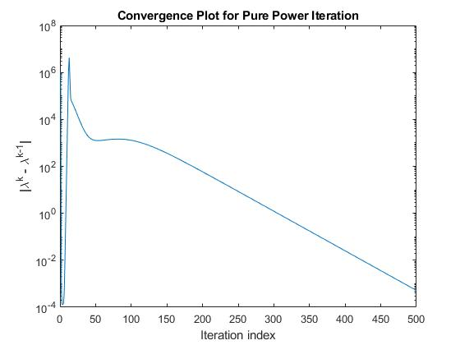

500 Iterations(tolerance of 10^-8 is not met)

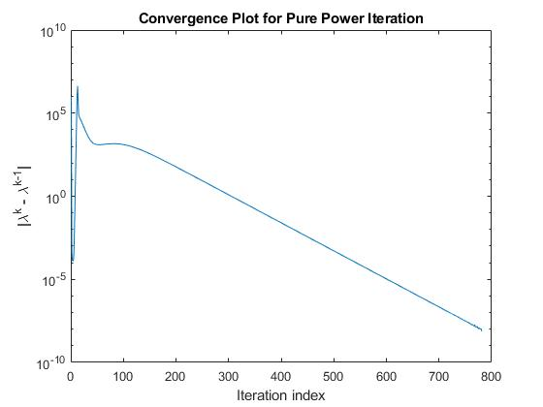

1000 Iterations(tolerance is met at 781 iterations)



5000 iterations(tolerance is met at 781th iterations

For: **s3rmt3m3.mtx** the maximum eigenvalue mentioned in matrix market is 9.5986080894852857E+03. And convergence plots for this matrix is shown in next section as comparison with Lanczos method.

***2. Run the Lanczos method for m = 30; 50; 75; 100, where m is the dimension of the Krylov Space. For the power iteration you can use a convergence criterion error < tol, For the tolerance tol you can use 10^-2 (m = 30), 10^-4 (m = 50), 10^-6 (m = 75), 10^-10 (m = 100).***

Maximum iterations are set to 5000, but in both methods tolerance is reached much before this. From here on we consider s3rmt matrix for further analysis. **Table in page 8** records needed data

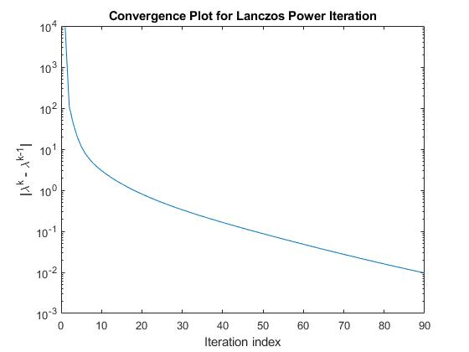

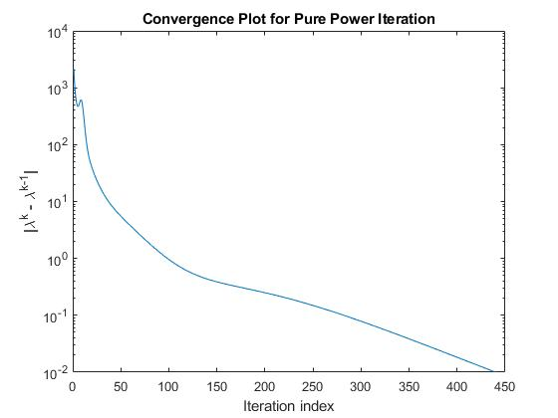

Plot 1 : with m=30, tol = 10^-2

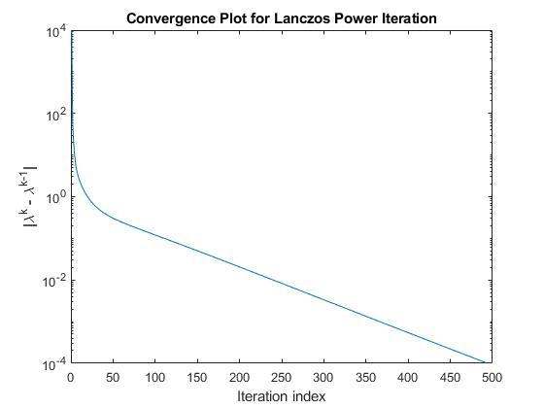

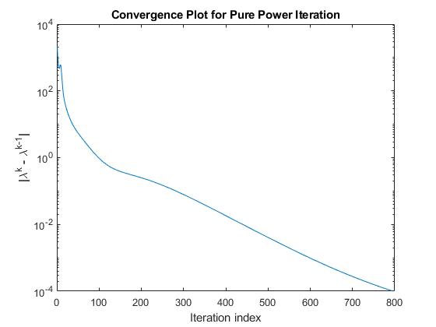

Plot2: with m=50, tol = 10^-4

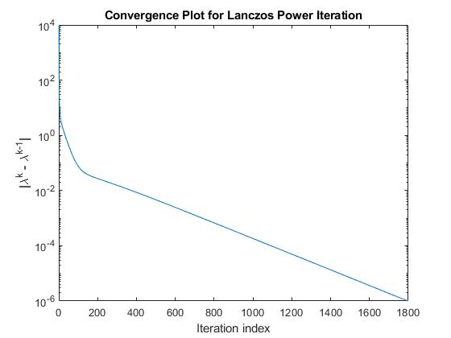

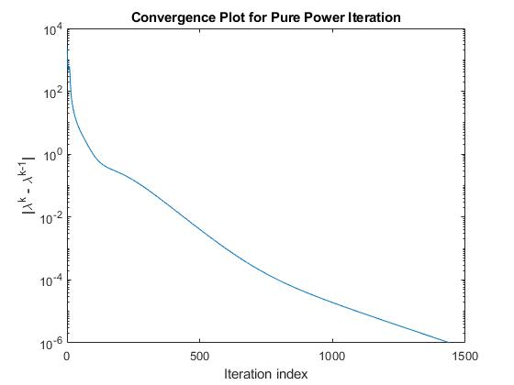

Plot 3: with m=75, tol = 10^-6

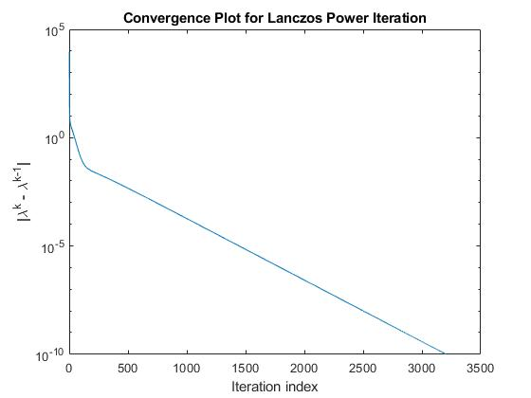 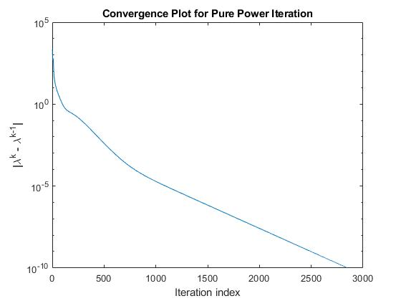

Plot 4: with m=100, tol = 10^-10

|  |  |  |  |  |  |  |  |
| --- | --- | --- | --- | --- | --- | --- | --- |
| **(m)** | **(tol)** | **Lanczos Method**  **RunTime in Sec** | **Pure Power Iteration Method RunTime in sec** | **Lanczos Method**  **Eigan Value** | **Pure Power Iteration Method Eigan Value** | **Lanczos Method**  **Error** | **Pure Power Iteration Method**  **Error** |
| 30 | 10^-2 | 0.002316 | 0.060369 | 9502.391150 | 9159.649882 | 0.0096722 | 0.0099617 |
| 50 | 10^-4 | 0.005030 | 0.393546 | 9567.921221 | 9581.213309 | 9.944*10^-05 | 9.953*10^-05 |
| 75 | 10^-6 | 0.006669 | 1.069396 | 9597.115324 | 9598.441637 | 9.970*10^-07 | 9.993*10^-07 |
| 100 | 10^-10 | 0.025214 | 3.228686 | 9598.607947 | 9598.608089 | 9.822*10^-11 | 9.822*10^-11 |

3***. Plot the error on a semi-log scale for both schemes against execution time***.

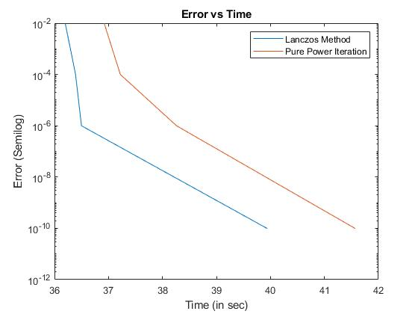

Plot 5: Error vs Run Time for Lanczos and Power Iteration method

We can observe that, to achieve the same convergence, Lanczos method takes lesser time than pure iteration method, because the smaller Hessenberg matrix of size ~(m*m) is used to find the Eigen value, unlike in power iteration which uses very large sparse matrix.